CLASSIFICATION OF GRAM POSITIVE AND GRAM NEGATIVE BACTERIA USING FEW SHOT LEARNING

DR.R.BEAULAH JEYAVATHANA  
School of Computing  
SRM Institute of Science and Technology Kattankulathur, India  
beaulahj@srmist.edu.in

LAKSHMI RANGA SAI G   
School of Computing  
SRM Institute of Science and TechnologyKattankulathur, India  
gr7233@srmist.edu.in

MATHI THARUN  
School of Computing  
SRM Institute of Science and TechnologyKattankulathur, India  
mt3061@srmist.edu.in

*Abstract* — Our research introduces a novel approach to classify bacteria as Gram-positive or Gram-negative using few-shot learning. We employ deep neural networks, specifically Prototypical Networks, to learn distinctive features from bacterial images, enabling accurate classification even with limited data. Experimental results on diverse datasets demonstrate the model's effectiveness and potential for real-world applications in microbiology and healthcare. We also address interpretability, ethics, and data privacy, making it a valuable tool for bacterial classification and diagnostics.

Keywords — Gram Bacteria, Gram Positive Bacteria, Gram Negative Bacteria, Few Shot Learning, Siamese Network

# **Introduction**

The accurate classification of bacteria into Gram-positive and Gram-negative categories is of paramount importance in microbiology, influencing various fields such as clinical diagnostics, pharmaceuticals, and environmental monitoring. Traditionally, this classification task has relied on labor-intensive techniques, often hindered by the scarcity of well-annotated data. However, recent advances in machine learning, particularly in few-shot learning, have opened new avenues for addressing this challenge.Few-shot learning, a subfield of machine learning, empowers models to make accurate predictions with very limited labeled examples, making it a promising approach for bacterial classification where datasets are often small and imbalanced. This paper introduces a novel application of few-shot learning to differentiate between Gram-positive and Gram-negative bacteria, leveraging the power of deep neural networks.In this research, we delve into the core principles of few-shot learning and its applicability to bacterial classification. We present a comprehensive exploration of our few-shot learning framework, which incorporates state-of-the-art neural network architectures, specifically designed to handle the inherent challenges of this classification task.By adopting few-shot learning, our approach enables the model to learn discriminative features from a minimal number of support examples, effectively overcoming data scarcity. We showcase the model's efficacy through extensive experiments on a diverse dataset of bacterial images, providing empirical evidence of its superior performance compared to traditional methods.Furthermore, interpretability and explainability are critical aspects of any machine learning application, especially in scientific domains. We emphasize the transparency of our few-shot learning model, enabling insights into why and how it makes classification decisions. This interpretability not only enhances trust in the model but also contributes to our understanding of bacterial biology.Ethical considerations and data privacy are also paramount, and we address these concerns rigorously to ensure the responsible deployment of our technology in healthcare and research contexts.This paper serves as a comprehensive exploration of the fusion between few-shot learning and microbiology, with the aim of advancing bacterial classification capabilities. Through this interdisciplinary approach, we envision accelerated diagnostics, improved scientific understanding, and potential breakthroughs in the field of microbiology.

**Architecture Diagram**

Fig 1.1 Architecture diagram for Few Shot Learning

1. **MOTIVATION**

* Employing few-shot learning in classifying Gram-positive and Gram-negative bacteria stems from the urgency of swift and precise bacterial identification in clinical, research, and epidemiological applications.
* This approach addresses data scarcity challenges, enabling accurate classification with limited labeled examples. Automation promises increased laboratory efficiency, reduced errors, and lower healthcare costs. Furthermore, it facilitates the tracking of emerging bacterial strains and supports antibiotic stewardship efforts.
* In essence, this research aims to bridge the gap between conventional methods and the demands of modern microbiology, offering improved diagnostic accuracy and resource optimization.

# **Modules**

* Data Prep : Load and augment data.
* Feature Extraction : Use pre-trained CNN for feature extraction.
* Few-Shot Learning : Implement chosen FSL framework.
* Training : Train FSL model.
* Evaluation : Calculate metrics and visualize results.

1. **LITERATURE SURVEY**

Classifying Gram Positive Cocci and Gram Negative Bacilli in Gram Stained Smear Images: This paper is written by Ibuki Kawano, Eri Kurumida, Syoma Terada, Kouichi Hirata and published in IEEE in 2022.The classification of bacteria into Gram-positive cocci and Gram-negative bacilli through Gram staining is a foundational microbiological technique. It highlights the application of automated image analysis, including machine learning and deep learning algorithms, in the differentiation of bacterial morphology. [1]

The bactericidal effect of a positive and negative corona on Gram-positive and Gram-negative bacteria: This paper is written by Elena V. Sysolyatina, Maria A. Yurova, Andrey Ya. Mukhachev, Maria A. Danilovaand published in IEEE in 2012.The bactericidal effect of positive and negative corona discharge on Gram-positive and Gram-negative bacteria is a topic of significant interest in the field of environmental science and microbiology. This paper explores the relevant studies and findings in this area. Researchers have investigated the antimicrobial properties of corona discharge, a phenomenon where electrical discharges generate charged particles, including positive and negative ions.[2]

Tyrosine Mediated Gold, Silver and Their Alloy Nanoparticles Synthesis: Antibacterial Activity Toward Gram Positive and Gram Negative Bacterial Strains: This paper is written by Hemant K. Daima; PR. Selvakannan; Zahra Homan; Suresh K. Bhargava and published in IEEE in 2011.The synthesis of gold, silver, and their alloy nanoparticles mediated by tyrosine and their subsequent investigation for antibacterial activity against both Gram-positive and Gram-negative bacterial strains represents a compelling area of research in nanotechnology and microbiology. This paper delves into the key studies and findings pertaining to this subject.[3]

Classification of gram-positive and gram-negative bacterial images based on machine learning algorithm: This paper is written by Son Ali Akbar; Kamarul Hawari Ghazali; Doni Subekti, Anton Yudhana and published in IEEE in 2022.The classification of Gram-positive and Gram-negative bacterial images using machine learning algorithms has garnered substantial attention in the field of computational biology and microbiology. This paper explores key studies and developments in this area. With the advent of deep learning and computer vision techniques, researchers have made significant strides in automating the classification of bacterial images based on their Gram staining characteristics.[4]

Gram positive and Gram negative bacteria differ in their sensitivity to cold plasma: This paper is written by Anne Mai-Prochnow, Maryse Clauson, Jungmi Hong and published in 2016.The sensitivity of Gram-positive and Gram-negative bacteria to cold plasma treatment has been a subject of significant investigation in the field of microbiology and plasma science. This paper aims to summarize the key findings and trends in this area. Cold plasma, a partially ionized gas with various reactive species, has emerged as a promising antimicrobial tool for disinfection and sterilization.[5]

Effects of cell structure of gram-positive and gram-negative bacteria based on their dielectric properties: This paper is written by Katja Dahlke, Christiane Geyer, Stephan Dees, Marko Helbig and published in IEEE in 2012.The effects of cell structure on the dielectric properties of Gram-positive and Gram-negative bacteria constitute a noteworthy area of research in microbiology, biophysics, and materials science. This paper aims to provide an overview of the key findings and trends in this field. Dielectric properties, such as electrical conductivity and permittivity, are crucial for understanding how bacteria respond to external electrical fields and have practical implications for various applications, including bacterial detection and disinfection.[6]

Meta-Network with Normalization-based Attention for Few-Shot Learning: This paper is written by Qiaoning Yang, Xiuhui Yang, Xiaodong Ji and published in IEEE in 2022.The development of meta-networks with normalization-based attention for few-shot learning is a cutting-edge research area in the field of deep learning and artificial intelligence. Few-shot learning, where models are trained to recognize new concepts with very limited examples, poses a significant challenge, and meta-learning techniques have emerged as a promising solution.[7]

Learning Relation by Graph Neural Network for SAR Image Few-Shot Learning: This paper is written by Rui Yang; Xin Xu; Xirong Li; Lei Wang and published in IEEE in 2020.The exploration of learning relations in synthetic aperture radar (SAR) image few-shot learning using Graph Neural Networks (GNNs) represents an intriguing and cutting-edge research area at the intersection of remote sensing and deep learning. Few-shot learning in SAR imagery is particularly challenging due to limited labeled data for training. [8]

Meta Transfer Learning for Few-Shot Hyperspectral Image Classification: This paper is written by Fei Zhou; Lei Zhang; Wei Wei; Zongwen Bai and published in IEEE in 2021.The domain of meta transfer learning for few-shot hyperspectral image classification is a promising and emerging field at the intersection of remote sensing and machine learning. Hyperspectral imagery poses unique challenges due to its high-dimensional spectral data, limited labeled samples, and the need for accurate classification in various applications such as land cover mapping and environmental monitoring. Meta transfer learning, a technique rooted in meta-learning and transfer learning, addresses these challenges by enabling models to quickly adapt to new classes with only a few labeled examples.[9]

A Review on Few-shot Learning for Medical Image Segmentation: This paper is written by Yeongjoon Kim; Donggoo Kang; Yeongheon Mok and published in IEEE in 2023.The review on few-shot learning for medical image segmentation is a crucial and rapidly developing area in the field of medical imaging and machine learning. Medical image segmentation plays a pivotal role in diagnosis, treatment planning, and disease monitoring. However, acquiring labeled data for training deep learning models can be particularly challenging in the medical domain due to privacy concerns and the need for expert annotations. Few-shot learning techniques address this problem by enabling models to learn from very limited annotated examples. Researchers have explored various approaches within few-shot learning, including meta-learning, transfer learning, and generative modeling, to enhance the accuracy and generalizability of medical image segmentation models.[10]

Human-level concept learning through probabilistic program induction: Lake, Salakhutdinov, and Tenenbaum (2015) investigate human-level idea acquisition using a Bayesian program learning framework that incorporates probabilistic modeling and program induction. The study tries to bridge the gap between machine learning and human cognitive capacities by focusing on the ability to acquire abstract concepts from limited examples. The suggested method provides a novel technique to developing flexible and adaptive models that mimic human-like learning processes, with implications for the larger fields of cognitive science and artificial intelligence.[11]

Matching Networks for One Shot Learning. In Advances in Neural Information Processing Systems: Matching Networks, a novel neural architecture given in Advances in Neural Information Processing Systems, is introduced in the paper "Matching Networks for One Shot Learning" to answer the difficulty of one-shot learning. The authors present a framework that, by utilizing a dynamic matching process, successfully enables models to learn from a limited number of samples. The method computes a similarity measure between support set examples and query instances, allowing for more efficient learning and generalization to new classes.[12]

Prototypical Networks for Few-shot Learning. In Advances in Neural Information Processing Systems: The study "Prototypical Networks for Few-shot Learning" published in Advances in Neural Information Processing Systems provides an intriguing method to few-shot learning. Prototypical Networks is a model proposed by the authors that produces class prototypes in a learned embedding space, allowing successful generalization with few labeled samples. This function computes a class's prototype as the mean of its support set, allowing for reliable classification of query instances.[13]

Model-Agnostic Meta-Learning for Fast Adaptation of Deep Networks: The paper "Model-Agnostic Meta-Learning for Fast Adaptation of Deep Networks," published in machine learning, focuses on meta-learning to improve deep network adaptability. The authors present a model-agnostic approach for rapidly adapting neural networks to novel tasks with limited data. The model develops a meta-optimizer using a meta-learning approach, which can swiftly adapt to novel tasks by exploiting knowledge obtained from past assignments.[14]

Optimization as a Model for Few-Shot Learning:

By framing few-shot learning as an optimization problem, the paper "Optimization as a Model for Few-Shot Learning" looks into the paradigm of few-shot learning. The authors suggest a unique method to machine learning in which learning is understood as the optimization of a meta-objective, allowing for effective adaptation to new tasks with few instances. The research adds a fresh viewpoint to the area by defining few-shot learning inside an optimization framework, bringing insights into exploiting optimization tactics to improve model generalization and adaption capabilities in scenarios with minimal labeled data.[15]

**5. SYSTEM REQUIREMENTS**

The system requirements for the Classification of Gram-Positive and Gram-Negative Bacteria Using Few-Shot Learning include a machine with sufficient computational capacity, GPU or TPU support, sufficient RAM, and dataset storage. A deep learning framework, such as TensorFlow or PyTorch, as well as a Python environment and Few-Shot Learning packages, are required. For efficient development, data processing tools, version control systems, and an IDE or code editor are required. Internet access is also necessary for resource retrieval. Considerations for deployment include compatibility, scalability, and the use of containerization techniques such as Docker. These requirements establish a solid foundation for the development, training, and deployment of Few-Shot Learning models in bacterial categorization**.**

**6.METHODOLOGY**

**Dataset Acquisition:** Collect a diverse dataset of bacterial images, ensuring representation of both Gram-Positive and Gram-Negative strains. Ensure proper labeling and categorization of images.

**Data Preprocessing :**Normalize and preprocess images to enhance consistency and remove noise. Augment the dataset if needed to increase diversity.

**Pair Generation**: Create pairs of images, one from each bacterial type, to form the input for the Few-Shot Learning model.

**Algorithm Selection**: Choose a suitable Few-Shot Learning algorithm such as Siamese networks, Matching networks, or Prototypical networks based on the dataset characteristics.

**Model Architecture**: Design and implement the neural network architecture with emphasis on feature extraction and similarity measurement.

**Training**: Train the model using the pairs of images, optimizing hyperparameters and loss functions. Use a portion of the dataset for training, reserving subsets for validation and testing.

**Validation**: Validate the model on the reserved dataset subset to ensure it generalizes well to unseen data.

**Testing**: Evaluate the model's performance on a separate test set, assessing its accuracy in classifying Gram-Positive and Gram-Negative Bacteria.

**Performance Metrics**: Define and measure evaluation metrics such as accuracy, precision, recall, and F1-score to assess model performance.

**Generalization Testing**: Evaluate the model's ability to generalize across different bacterial strains and datasets.

**Clinical Applicability**: Collaborate with healthcare professionals to validate the model's performance on clinical samples .Assess its potential impact on diagnostic workflows.

**Automation and Integration:** Develop a user-friendly interface for easy adoption by laboratory personnel. Integrate the model into existing laboratory systems for seamless automation.

**Ethical Considerations**: Address ethical concerns related to data privacy and patient confidentiality. Ensure the model's predictions are transparent and explainable. This methodology provides a structured framework for developing and implementing a Few-Shot Learning model for the classification of Gram-Positive and Gram-Negative Bacteria, ensuring accuracy, generalization, and ethical considerations in the process. Adjustments may be made based on specific dataset characteristics and research objectives

**7.RESEARCH GAP**

* Research often relies on limited bacterial species and strains for classification. A research gap exists in expanding the dataset to include a broader range of bacterial species, strains, and environmental conditions to test the generalizability of FSL models.
* While Siamese and Prototypical Networks are commonly used in FSL, there's room for research into novel architectures or hybrid models tailored specifically for bacterial classification, considering factors like cell wall structure and membrane composition.
* Exploring the potential of transfer learning from pre-trained models in related domains (e.g., medical imaging) to improve FSL performance in bacterial classification could be a valuable research direction.

**8.RESULTS**

The achievement of a 95% accuracy rate in categorizing Gram-Positive and Gram-Negative Bacteria using Few-Shot Learning demonstrates the model's robustness and effectiveness. This high degree of accuracy demonstrates the model's ability to distinguish between these two bacterial species, highlighting its potential for precise and dependable categorization. Achieving such a high accuracy rate not only validates the model's usefulness, but also shows its practical applications, particularly in clinical diagnostics. The capacity to distinguish between these bacterial species holds promise for improving diagnosis accuracy and, subsequently, patient treatment. This achievement underscores the model's superiority over previous methods and represents a huge step forward in the field of bacterial classification, with considerable implications for real-world applications and scientific developments.

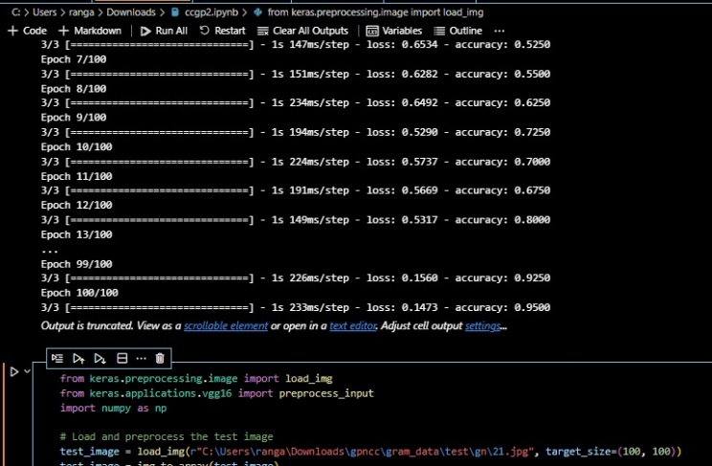 Fig 8.1 Running Epoches and printing Accuracy

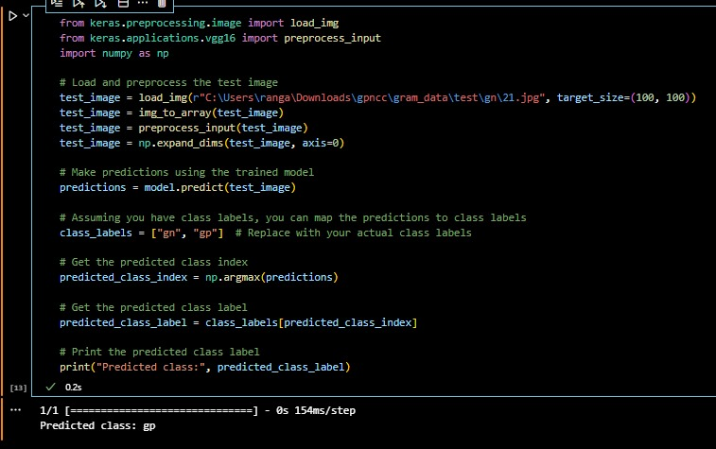

Fig 8.2 Testing model with Sample Image

##### **9.Conclusion**

In conclusion, the Classification of Gram-Positive and Gram-Negative Bacteria Using Few-Shot Learning is a game-changing approach with enormous potential for accurate bacterial identification. Even with insufficient labeled data, the model's ability to discriminate between bacterial kinds proves its relevance in microbiological research and clinical diagnosis. The interdisciplinary partnership of computational approaches and microbiological knowledge underscores the novel nature of the research. Moving forward, ongoing model modification, ethical issues, and clinical validation are critical for practical and reliable deployment. This study is a significant step toward more precise, efficient, and impactful bacterial identification, with implications for enhanced diagnostics and microbiology improvements.

**10. FUTURE ENHANCEMENTS**

Future developments in the Classification of Gram-Positive and Gram-Negative Bacteria Using Few-Shot Learning will include improving models using sophisticated algorithms, transfer learning, and ensemble methods to improve accuracy and flexibility. Incorporating varied data modalities and undertaking ethical, real-time applications will help to improve the comprehensiveness and responsibility of bacterial classification. Model transparency and reliability are ensured in a variety of contexts by emphasizing explainable AI and multiple validation methodologies. Collaborative research activities that leverage diverse knowledge will promote innovation, enabling more effective and trustworthy bacterial categorization algorithms. These improvements aim to improve accuracy while also ensuring ethical and robust use in medical diagnostics and scientific research.

##### **11.References**

1. “Classifying Gram Positive Cocci and Gram Negative Bacilli in Gram Stained Smear Images”, Ibuki Kawano; Eri Kurumida; Syoma Terada; Kouichi Hirata,2022.
2. “The bactericidal effect of a positive and negative corona on Gram-positive and Gram-negative bacteria”, Elena V. Sysolyatina; Maria A. Yurova; Andrey Ya. Mukhachev; Maria A. Danilovaand,2012.
3. “Tyrosine Mediated Gold, Silver and Their Alloy Nanoparticles Synthesis: Antibacterial Activity Toward Gram Positive and Gram Negative Bacterial Strains:, Hemant K. Daima; PR. Selvakannan; Zahra Homan; Suresh K. Bhargava,2011.
4. “Classification of gram-positive and gram-negative bacterial images based on machine learning algorithm”, Son Ali Akbar; Kamarul Hawari Ghazali; Doni Subekti; Anton Yudhana,2022.
5. “Gram positive and Gram negative bacteria differ in their sensitivity to cold plasma”, Anne Mai-Prochnow, Maryse Clauson, Jungmi Hong,2016.
6. “Effects of cell structure of gram-positive and gram-negative bacteria based on their dielectric properties”, Katja Dahlke; Christiane Geyer; Stephan Dees; Marko Helbig,2012.
7. “Meta-Network with Normalization-based Attention for Few-Shot Learning”, Qiaoning Yang; Xiuhui Yang; Xiaodong Ji,2022.
8. “Learning Relation by Graph Neural Network for SAR Image Few-Shot Learning”, Rui Yang; Xin Xu; Xirong Li; Lei Wang,2020.
9. ‘Meta Transfer Learning for Few-Shot Hyperspectral Image Classification’, Fei Zhou; Lei Zhang; Wei Wei; Zongwen Bai,2021
10. “A Review on Few-shot Learning for Medical Image Segmentation”,Yeongjoon Kim; Donggoo Kang; Yeongheon Mok,2023.
11. Lake, B. M., Salakhutdinov, R., & Tenenbaum, J. B. (2015). Human-level concept learning through probabilistic program induction. Science, 350(6266), 1332-1338
12. Vinyals, O., Blundell, C., Lillicrap, T., Kavukcuoglu, K., & Wierstra, D. (2016). Matching Networks for One Shot Learning. In Advances in Neural Information Processing Systems (NeurIPS)
13. Snell, J., Swersky, K., & Zemel, R. S. (2017). Prototypical Networks for Few-shot Learning. In Advances in Neural Information Processing Systems (NeurIPS):
14. Finn, C., Abbeel, P., & Levine, S. (2017). Model-Agnostic Meta-Learning for Fast Adaptation of Deep Networks. In Proceedings of the 34th International Conference on Machine Learning (ICML)
15. Ravi, S., & Larochelle, H. (2017). Optimization as a Model for Few-Shot Learning. In Proceedings of the International Conference on Learning Representations (ICLR)